10/18/23 → Since last time, I completely started from scratch. I decided to try to build something off of a theme/phrase, which I picked to be “out with the old, in with the new”. I looked this phrase up in Google for ideas and found this image and I liked how simple and clear it was. I based my new idea/design off of this. In the previous design, I had already managed to use tools like Text, Color Picker, Paint, and Erase. This time around, with a more concise idea, I struggled figuring out how to use tools like Fill, Fuzzy Select, Select by Color, and Paths to make my vision happen. Fonts was another thing I wanted to work on because it would have been cool to match Apple’s font like Google/Android did in their #GetTheMessage campaign ads! I then got the idea to make it somewhat symmetrical and in nature and chose to incorporate the green and blue text bubbles into the mix themselves. I like that my new design is more clear and hopefully easier to understand without having much background knowledge on the issue!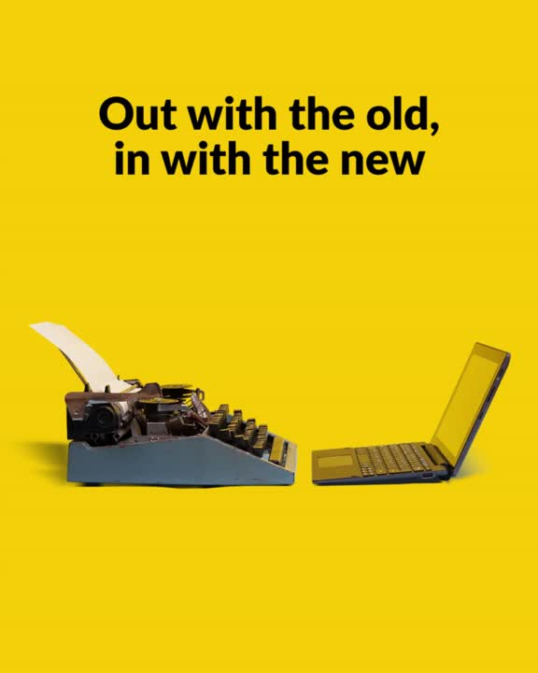

10/11/23 → So as soon as we introduced this project, I thought that I would end up trying out an album cover. I quickly realized that this was not the direction I wanted to go with after seeing examples of others' projects. I wanted to make a witty but serious stand and get people's attention with my message. I thought of a lot of controversies and things I find to be unfair, and big companies/corporations came to mind.

I own no more than 3 Apple products, however; I have strong disdain for them as a company. The choices they make and things they do never sit right with me. One thing I can't stand is the lack of integration between Androids/other smartphones and iPhones. iMessage is a big example of where Apple loves to be a big bully.

They knowingly use an old, outdated software called SMS/MMS. It's from the 90s and it causes texting between any phone that is not also an iPhone a potentially frustrating experience. You end up with low-resolution videos, no encryption, and missing features (no read receipts and group chats are hard to go about). They choose to keep using this when there is RCS, which solves all these problems, and almost all other smartphones these days use! As always they are stubborn and want to gatekeep their stuff so bad they make everyone suffer, even their own users.

In my visual argument, I try to emphasize Apple's selfishness and foolishness on this matter and how they are the problem in this situation. They have the ability to simply solve these issues but time and time again let everyone down. It's childish and annoying!

I wanted to make mine more like a meme so it would be funny but still informative. I used cropping, painting, color picking, move, scale, and more when it came to tools to put this preview together.